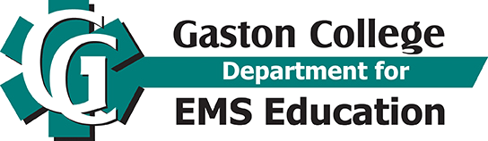
Course cost

Cost Without Tuition Waiver | Cost with Tuition Waiver

$180 Tuition

$6 Usage Fee

$5 Technology Fee
$191.00 Tuition and Fees Payable to Gaston College | No Tuition Cost if Waived
Continuing Education

Continuing Education

Paramedic Refresher Course

EMS 7408-01

Dallas Campus APS 131
January 18 – March 21, 2021
60-hour Online Hybrid
40 hours online
2 days onsite - 8:00am-7:00pm

Class location, Dallas Campus
LMS Blackboard Online and Location: Gaston College, Albright Public Safety Building, Room 131

Course Description
The curriculum for the EMS paramedic refresher educational program meets the minimum requirements for Re-Credentialing using the National Continued Competency Requirements (NCCP) including national, local and individual requirements from the National Registry of EMTs paramedic recertification. This course meets 60 (one-half) of the 120 hours of the NCOEMS 4-year recertification period. The Education Standards have been adopted by the North Carolina Association of Emergency Medical Service Educators and approved by the North Carolina Office of Emergency Medical Services.

EMS Credential Status
- Currently holds a valid North Carolina, NREMT or other State EMS paramedic Credential
- Held a paramedic Level North Carolina EMT Credential that has expired within the last four (4) years.
- *NC Paramedics Only: If you are applying for recredentialing or attending this program for recertification, you can either:
    - Attend an additional 60-hour refresher course
    - Use additional “canned courses” such as ACLS, PALS, BLS, PHTLs, ITLS, etc.

No Additional Resources Required

You should use this Paramedic Refresher if:

- You are an expired paramedic or soon to expire in NC and need a paramedic Refresher Course.
- You need a paramedic Refresher to maintain your NREMT certification.
- You failed the NREMT paramedic exam 3 times and need remedial training.
- Your NREMT has expired and you are needing to apply under the NREMT re-entry policy.

How Do I Register?
Albright Public Safety Building, Room 104.
- First Day of Registration is January 4, 2021
- Last day to register is January 13, 2021

Items you MUST bring with you to register:

- Completed registration form
- Tuition and fees, and/or approved waiver verification letter signed by agency on letterhead Note: Tuition and/or fees payment (check, cash accepted)
- Note: Can pay by credit or debit card in Gaston College Business Office once registered.

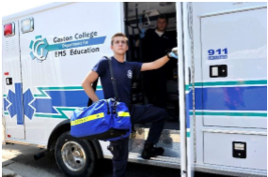

For More Information: Department for EMS Education
Office 704-922-62Email: gcems@gaston.edu

