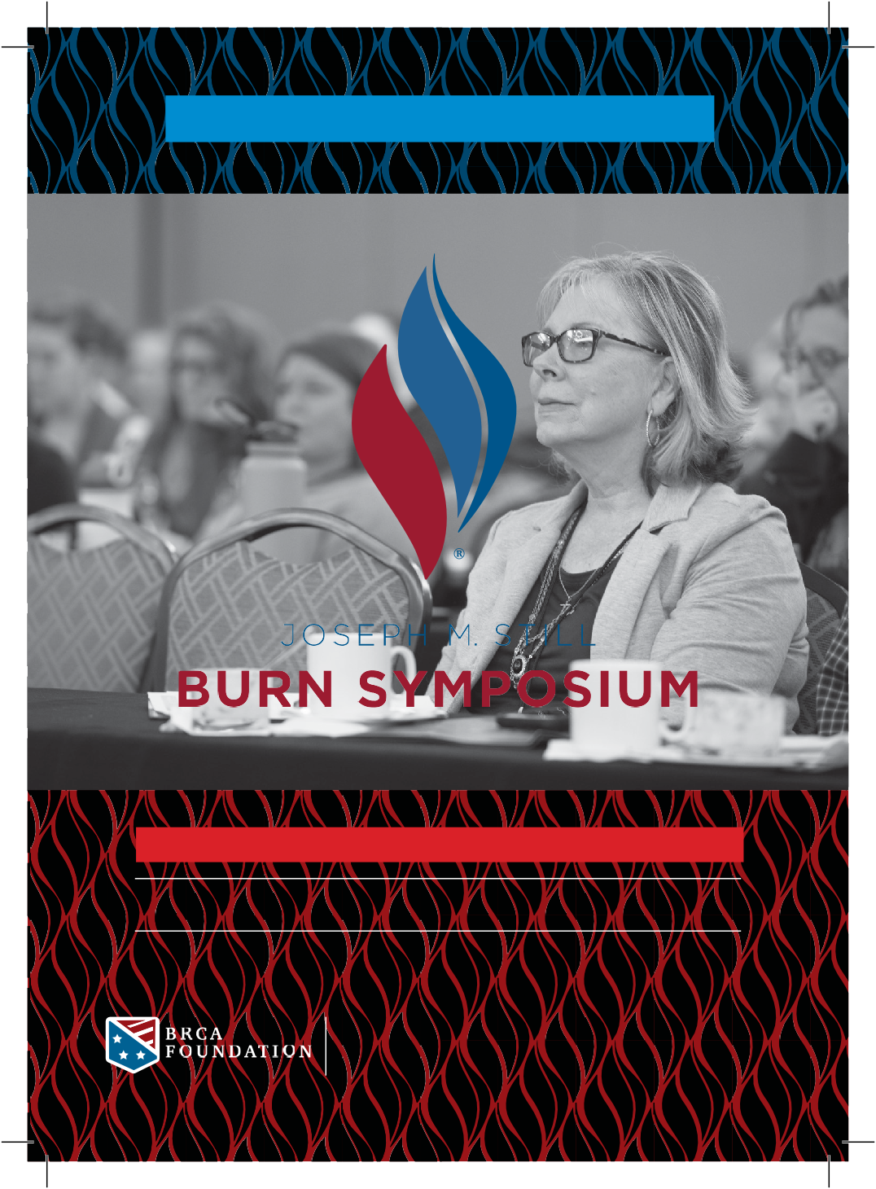
S A V E the D AT E

FEBRUARY 28 - MARCH 1, 2021
CHÂTEAU ÉLAN | BRASELTON, GEORGIA

In-person and virtual attendance options will be available.

www.BurnCenters.com/Symposium
Joseph M. Still Burn Symposium is hosted by BRCA Foundation.

